DAV Senior Secondary School

Computer Science Project

Quiz

Done By:

Karthick S.

Shiva Kanth Sujit

Vishnu Srinivasa Prasad

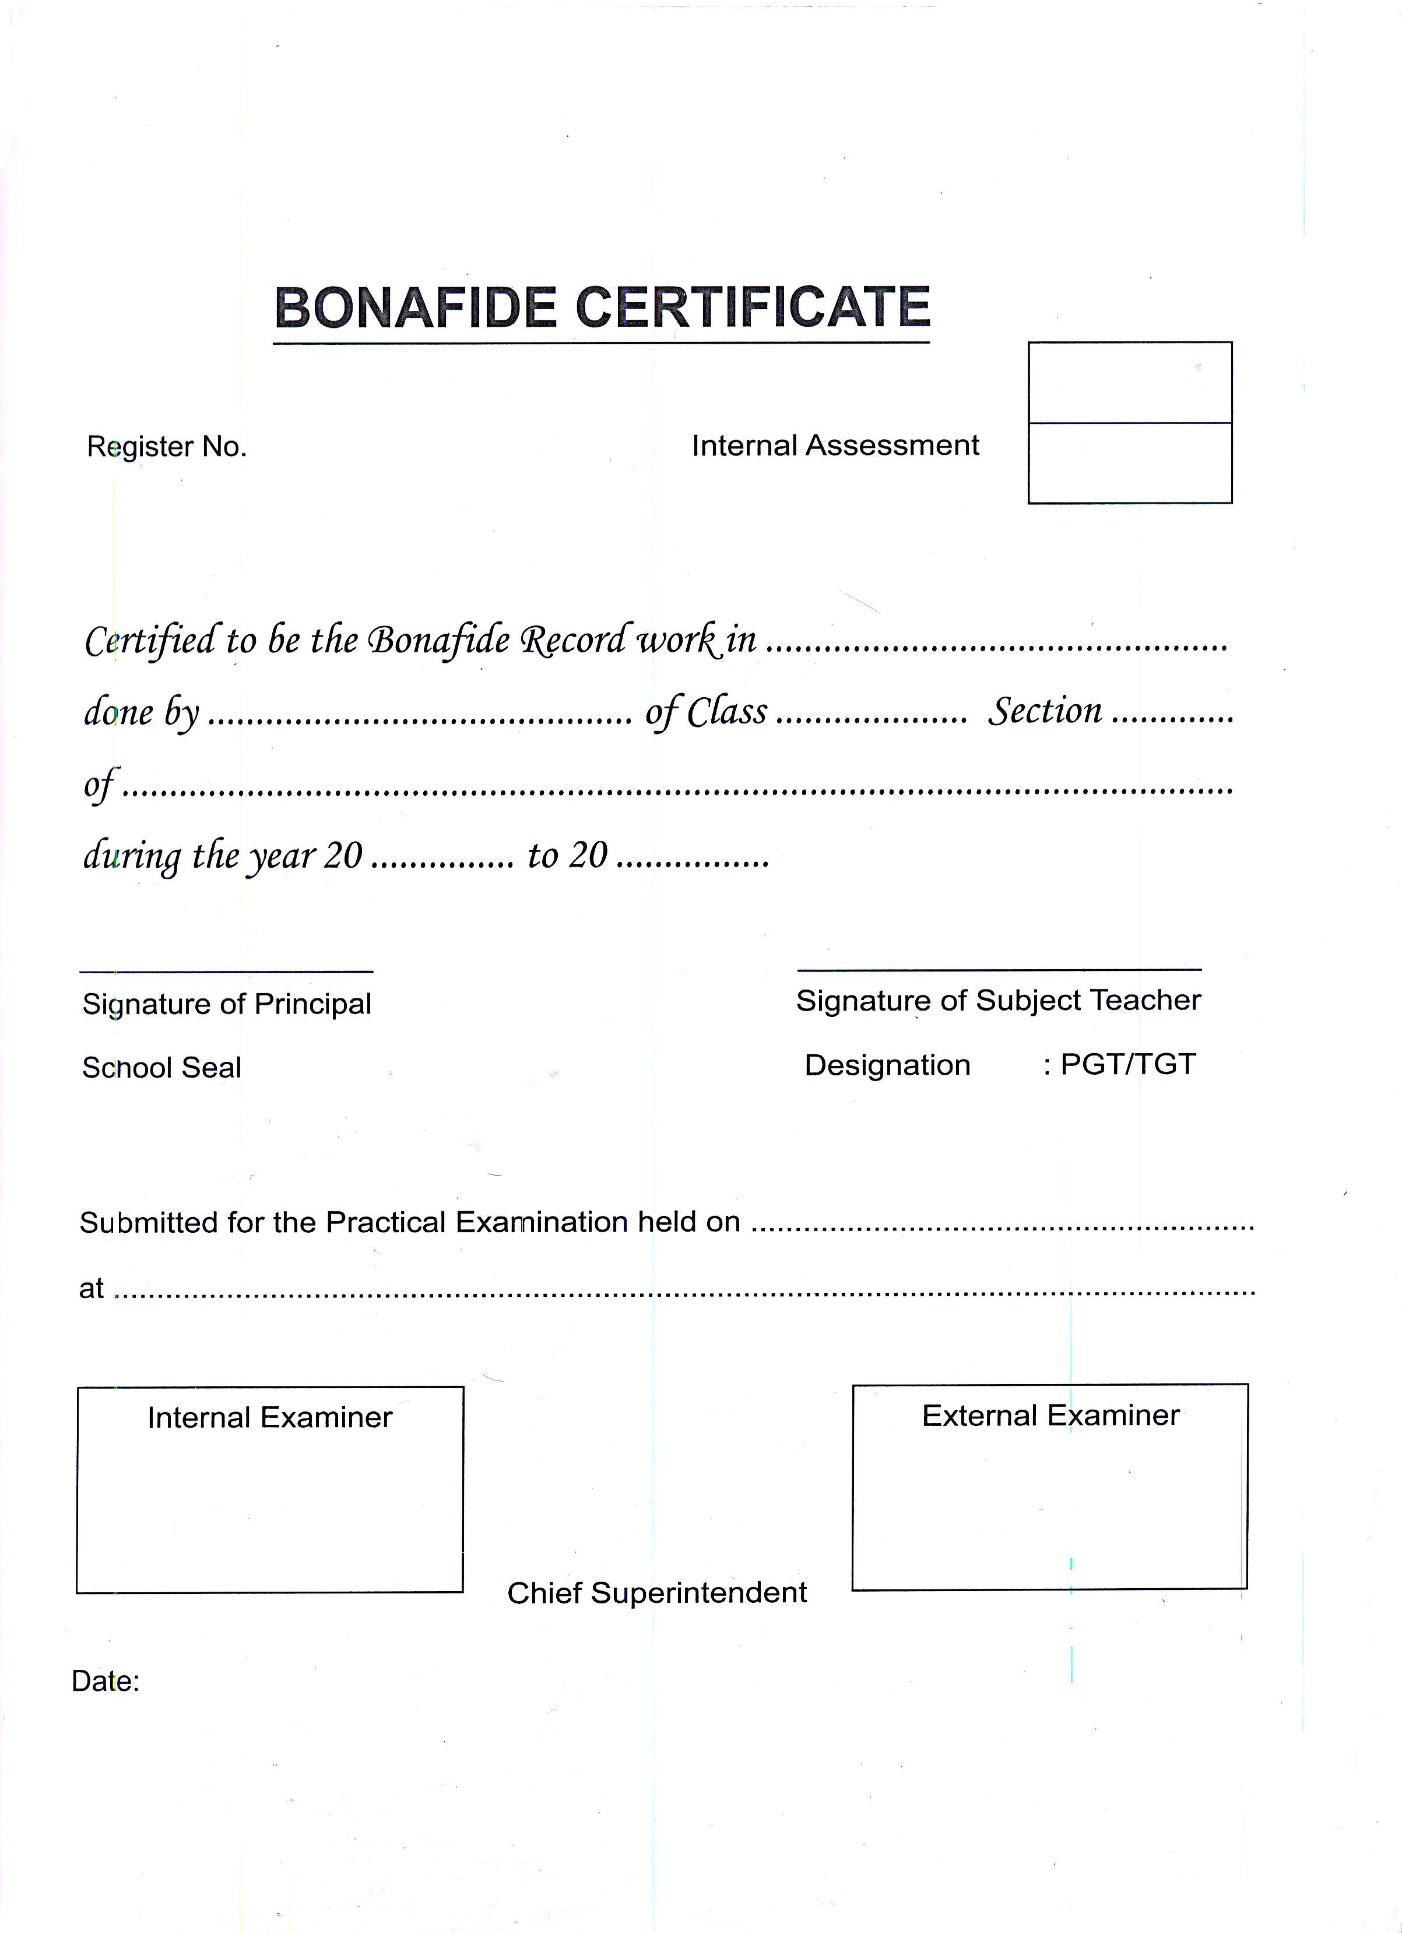

**Acknowledgement**

I avail this opportunity to express my gratitude to my school Principal , Mrs. Lalitha Thiagarajan , and my

Computer Science teacher , Mrs. Uma Arthi , for their guidance and suggestions during the course of this project. I would also like to thank my parents , family and friends who have guided me in my endeavours.

**Index**

* Bonafide Certificate
* Acknowledgement
* Index
* Introduction
* Files Used
* Source Code
* Screenshots
* System Requirements
* Bibliography

**Introduction**

The goal of this project was to create a project to emulate a quiz program that would enable the user to play an engaging game , which while simple in aesthetics , would be easy to expand .

The quiz consists of four categories, namely Science, Pop Culture , History and Miscellaneous , each having 12 questions.

The user can create player profiles to store his progress so as to continue his game at a later time if he wants to. Each player profile is protected with a user-specified password that he chooses when he creates the profile.

There is an admin account included which can be used to modify the questions and their options . This account is password protected and can be accessed using the login screen at the beginning or the end of the game .

The game also stores the top five scores and the respective player names . These are displayed at the end of the game. Duplicate records are merged. If a player resumes his game, his latest score only will be stored.

**Files used**

There are three program files

* Open.cpp // contains the opening screens and header files
* Quiz.cpp // contains the main program code
* Ques.cpp // contains the code to create the databases

Besides these, a few binary files are created to manage the various aspects of the program

* Player.dat
* Science.dat
* PopCultu.dat
* History.dat
* Misc.dat
* High.dat

**Source Code:**

//Quiz.cpp

#include "open.cpp"

#include <string.h>

#include <fstream.h>

#include <iomanip.h>

union REGS in,out;

void callmouse()

{

in.x.ax=1;

int86(51,&in,&out);

}

void mouseposi(int &xpos,int &ypos,int &click)

{

in.x.ax=3;

int86(51,&in,&out);

click=out.x.bx;

xpos=out.x.cx;

ypos=out.x.dx;

}

struct player

{

char n[10];

int score;

int cat,c[4];

int qno[4][12];

int qon[4];

char pass[10];

player()

{

strcpy(n,"N/A");

score=0;

c[0]=c[1]=c[2]=c[3]=5;

qon[0]=qon[1]=qon[2]=qon[3]=12;

}

};

int mousecheck(int,int,int); // To return the option selected by the user

int mouseopt(int,int,int); // Category Selection

int mexit(int,int,int); // To exit the quiz

void admin(void); // Admin login authentication

int opt(void); // To display the catergories

void modify(int,int); // For the admin to modify the databases

void adminmain(void); // The main admin dashboard

void modhigh(); // To change the high scores

void dishigh(); // To display the high scores

struct A

{

char ques[80];

char ans[4][40];

char ano[40];

};

void main()

{

clrscr();

int gdriver = DETECT, gmode;

initgraph(&gdriver, &gmode, "C:\\TC\\BGI");

float x=getmaxx(),y=getmaxy();

char abc;

int pos[4]={ x*0.125 , x*0.60 , (y/2)+60 , (y/2)+90 };

setbkcolor(BLUE);

setcolor(WHITE);

settextjustify(1,1);

settextstyle(8,0,7);

outtextxy(x/2,50,"Quiz");

settextstyle(0,0,1);

outtextxy(x*0.8,10,"L for Login");

outtextxy(x*0.8-5,20,"H for High Scores");

outtextxy(x/2,y-100,"PRESS ANY KEY TO CONTINUE");

delay(500);

abc=getch();

if(abc=='l' || abc=='L')

admin();

else if(abc=='h' || abc=='H')

{

dishigh();

outtextxy(x/2,y-100,"If you want to now play , press P ");

outtextxy(x/2,y-80,"Any other key will exit the game");

char p=getch();

if(p=='p')

main();

else

exit(0);

}

cleardevice();

settextjustify(1,1);

outtextxy(x/2,y*0.25," Basic Rules");

outtextxy(x/2,y*0.375," Choose the category of your choice");

outtextxy(x/2,y*0.375+15," The questions will appear on the screen , use the mouse to select your choice");

outtextxy(x/2,y*0.375+30," Upon selecting your choice your score will be displayed on the screen");

outtextxy(x/2,y*0.375+45," To exit the quiz , click the red cross button on the top right corner of the screen");

outtextxy(x/2,y*0.375+60," You will get the choice of playing again while exiting");

outtextxy(x/2,y*0.6+75," Now press any key to start ..........");

getch();

callmouse();

int ch1=0;

player t;

char file[4][15]={"Science.dat","Pop Cultu.dat","History.dat","Misc.dat"};

do

{

clrscr();

cleardevice();

quizmain:

int op,n,playerchoice;

cout<<" 1- Returning Player 2- New Player\n Enter choice : ";

cin>>playerchoice;

int playerno=1;

int recpla;

int pno;

if(playerchoice==1)

{

ifstream displayer("Player.dat");

player d;

clrscr();

cleardevice();

cout<<"\n\n Players Available on Disk \n\n";

while(displayer.read((char *)&d,sizeof(d)))

{

cout<<"\t"<<playerno++<<"."<<d.n<<endl;

}

displayer.close();

cout<<"\n";

displayer.open("Player.dat");

if(playerno!=1)

{

char vishnu[10];

do

{

do

{

cout<<" Enter no : ";

cin>>pno;;

}while(pno>playerno);

int sh=((pno-1)*sizeof(t));

displayer.seekg(sh);

displayer.read((char *)&d,sizeof(d));

cout<<" \n Enter password for "<<d.n<<" : ";

gets(vishnu);

if(strcmpi(vishnu, d.pass)!=0)

cout<<"Invalid Password .\n\n";

}while(strcmpi(vishnu, d.pass)!=0);

recpla=1;

}

t=d;

do

{

clrscr();

cleardevice();

cout<<"\n\n\n The player you have chosen is "<<t.n<<endl<<" Your current score is "<<t.score<<endl;

if(t.qon[0]==0 && t.qon[1]==0 && t.qon[2]==0 && t.qon[3]==0)

{

cout<<"\n\t You Have finished all the questions in all the catergories . \n\t Start afresh? : ";

char stovr;

cin>>stovr;

if(stovr=='y')

{

cout<<" Reseting Score .......";

getch();

t.qon[0]=t.qon[1]=t.qon[2]=t.qon[3]=12;

t.score=0;

}

else

{

cout<<" Exiting ......";

dishigh();

getch();

exit(0);

}

}

if(t.qon[t.cat]==0)

{

cout<<" You have finished all the questions in the category "<<file[t.cat]<<" \n Please choose another .";

getch();

clrscr();

cleardevice();

op=opt();

clrscr();

t.cat=op;

}

getch();

clrscr();

cleardevice();

cout<<" Your category is "<<file[t.cat]<<" ";

getch();

}while( t.qon[t.cat]==0);

displayer.close();

}

if( playerno==1 || playerchoice!=1)

{

for(int z=0;z<4;++z)

for(int z1=0;z1<12;++z1)

t.qno[z][z1]=z1;

recpla=2;

cout<<"\n\n\n\n\n\n\n\n\n\n\n\t\t\t Enter Player Name : ";

gets(t.n);

int k1=0;

do

{

cout<<"\t\t\t Enter password : ";

gets(t.pass);

ifstream pa("Player.dat",ios::binary);

k1=0;

player k2;

while(pa.read((char *)&k2,sizeof(k2)))

{

if(strcmpi(k2.pass,t.pass)==0 && strcmpi(t.n,k2.n)==0)

k1++;

}

if(k1!=0)

cout<<"\n\t\tPlease choose another password .......\n\n ";

}while(k1!=0);

clrscr();

cleardevice();

op=opt();

clrscr();

t.score=0;

t.cat=op;

t.qon[t.cat]=12;

}

cleardevice();

int q,r,mx,my,mcl,ch;

ifstream data(file[t.cat],ios::binary);

A quiz[12];

data.read((char *)&quiz,sizeof(quiz));

setcolor(WHITE);

randomize();

int karthick=0;

while(t.qon[t.cat] && karthick<12)

{

karthick++;

r=random(4);

int ab=r;

q=random(t.qon[t.cat]);

settextjustify(0,1);

int serial=13-t.qon[t.cat];

char qop[50];

sprintf(qop,"%d.",serial);

outtextxy(x*0.09,y*0.125,qop);

outtextxy(x*0.125,y*0.125,quiz[t.qno[t.cat][q]].ques);

settextjustify(1,1);

setfillstyle(1,WHITE);

bar(x*0.9+10,10,x*0.95,20);

setcolor(RED);

line(x*0.9+10,10,x*0.95,20);

line(x*0.95,10,x*0.90+10,20);

setcolor(WHITE);

for(int k=2;k<4;++k)

for(int j=0;j<2;++j) // for the answer options

{

settextjustify(0,1);

circle(pos[j],pos[k],3);

outtextxy(pos[j]+10, pos[k], quiz[t.qno[t.cat][q]].ans[r%4] );

r++;

settextjustify(1,1);

}

ch=0;

int e=0;

do

{

mouseposi(mx,my,mcl);

delay(50);

cout<<'\r';

ch=mousecheck(mx,my,mcl);

e=mexit(mx,my,mcl);

if(e)

break;

if(ch)

{

settextstyle(0,0,1);

char sco[50];

sprintf(sco,"Your choice is %d .",ch);

outtextxy(x*0.750,y*0.75,sco);

if( strcmp (quiz[t.qno[t.cat][q]].ano ,quiz[t.qno[t.cat][q]].ans[ (ab+ch-1)%4 ] ) ==0 )

{

t.score++;

outtextxy(x*0.175,y*0.75,"Correct Answer!! ");

}

else

outtextxy(x*0.175,y*0.75,"Wrong Answer!! ");

}

}while(!ch);

char sc[50];

sprintf(sc,"Your Score is: %d",t.score);

outtextxy(x*0.175,y*0.85,sc);

for(int a=q;a<t.qon[t.cat]-1;++a)

t.qno[t.cat][a]=t.qno[t.cat][a+1];

t.qon[t.cat]--;

delay(1600);

cleardevice();

if(e)

break;

}

cleardevice();

char sc[50];

sprintf(sc,"Your Score is: %d",t.score);

outtextxy(x*0.5,y*0.4,sc);

fstream tf("Player.dat",ios::binary | ios::in | ios::out );

if(recpla==1)

{

int playercount=(pno-1)*sizeof(t);

tf.seekp(playercount);

player t1;

tf.read((char *)&t1,sizeof(t1));

tf.seekp((int)(-1*sizeof(player)),ios::cur);

}

else

tf.seekp(0,ios::end);

player d1;

d1=t;

tf.write((char *)&d1,sizeof(d1));

tf.close();

modhigh();

settextstyle(0,0,1);

outtextxy(x/2,y/2,"Do you wish to play again ?");

bar(x/2-50,y/2+20,x/2-30,y/2+40);

bar(x/2+30,y/2+20,x/2+50,y/2+40);

outtextxy(x/2-20,y/2+30,"Y");

outtextxy(x/2+20,y/2+30,"N");

ch1=0;

do

{ ch1=0;

mouseposi(mx,my,mcl);

delay(50);

cout<<'\r';

if(mcl==1)

{

if(mx>x/2-50 && mx<x/2-30 && my>y/2+20 && my<y/2+40)

ch1=1;

else if (mx>x/2+30 && mx<x/2+50 && my>y/2+20 && my<y/2+40)

ch1=2;

}

}while(!ch1);

data.close();

}while(ch1==1);

dishigh();

getch();

cleardevice();

settextjustify(1,1);

outtextxy(x*0.5,y*0.625,"Press L to Login");

outtextxy(x/2,y*0.8,"Press any other key to exit........");

char l;

l=getch();

if(l=='l')

admin();

closegraph();

clrscr();

}

int mousecheck(int mx,int my, int mcl)

{ int opt=0;

float x=getmaxx(),y=getmaxy();

int pos [4]={ x*0.125 , x*0.60 , (y/2)+60 , (y/2)+90 };

if(mcl==1)

{

if( mx<pos[0]+5 && mx>pos[0]-5)

{ if ( my<pos[2]+5 && my>pos[2]-5 )

opt= 1;

else if ( my<pos[3]+5 && my>pos[3]-5 )

opt= 3;

}

else if( mx<pos[1]+5 && mx>pos[1]-5)

{ if ( my<pos[2]+5 && my>pos[2]-5 )

opt=2;

else if ( my<pos[3]+5 && my>pos[3]-5 )

opt=4;

}

}

return opt;

}

int opt(void)

{

float x=getmaxx(),y=getmaxy();

int opt=-1,mx=0,my=0,mc=0;

bar(x*0.1875,y*0.250,x*0.433,y*0.433);

bar(x*0.567,y*0.250,x*0.8125,y*0.433);

bar(x*0.1875,y*0.625,x*0.433,y*0.808);

bar(x*0.567,y*0.625,x*0.8125,y*0.808);

char head[4][20]={"Science","Pop Culture","History","Misc."};

settextjustify(1,1);

setcolor(RED);

outtextxy(x*0.3102,y*0.3415,head[0]);

outtextxy(x*0.6895,y*0.3415,head[1]);

outtextxy(x*0.3102,y*0.7165,head[2]);

outtextxy(x*0.6895,y*0.7165,head[3]);

do

{

mouseposi(mx,my,mc);

opt=mouseopt(mx,my,mc);

}while(opt==-1);

cleardevice();

return opt;

}

int mouseopt(int mx,int my,int mc)

{

float x=getmaxx(),y=getmaxy();

int opt=-1;

if(mc)

{

if(mx>x*0.1875 && mx<x*0.433)

{

if(my>y*0.25 && my<y*0.433)

opt=0;

else if(my>y*0.625 && my<y*0.808 )

opt=2;

}

else if(mx>x*0.567 && mx<x*0.8125)

{

if(my>y*0.25 && my<y*0.433)

opt=1;

else if(my>y*0.625 && my<y*0.808 )

opt=3;

}

}

return opt;

}

int mexit(int mx, int my, int mc)

{ float x=getmaxx();

int a=0;

if(mx>x*0.9 && mx<x*0.95 && my>10 && my<20 && mc==1 )

a=1;

return a;

}

void admin(void)

{

float x=getmaxx(),y=getmaxy();

ad:

clrscr();

cleardevice();

cout<<"\n\n\n\n\n\n\n\n\n\n\t\t\t Enter user name : ";

char u,user[20],p,pass[20];

gets(user);

strcat(user,".txt");

ifstream f1(user);

if(!f1)

{

outtextxy(x/2-40,y*0.7,"Invalid Username");

getch();

goto ad;

}

int a=0;

outtextxy(x/2-70,y/2+40,"Enter password : ");

outtextxy(x/2+(10*a),y/2+80,"Press space to continue.....");

while((p=getch())!=' ')

{

pass[a]=p;

pass[a+1]='\0';

a++;

outtextxy(x/2+(10*a),y/2+40,"*");

}

if(strcmpi(pass,"pass"))

{

outtextxy(x/2-40,y*0.7,"Invalid password");

getch();

goto ad;

}

f1.close();

adminmain();

}

void adminmain(void)

{

int ch,ch1;

clrscr();

cleardevice();

cout<<"\n\n\t Which category would you like to modify ? \n\n\t 1- Science \t 2- Pop Culture \t 3- History \t 4- Misc ";

cout<<"\n\n Enter your choice : ";

cin>>ch;

cout<<"\n\n\t\t 1- Edit a question \n\n \t\t 2- Remove a question ";

cout<<" \n\n Enter your choice : ";

cin>>ch1;

modify(ch,ch1);

}

void modify(int a,int b)

{

a--;

char file[4][15]={"Science.dat","Pop Cultu.dat","History.dat","Misc.dat"};

fstream data(file[a],ios::binary | ios::in | ios::out);

A quiz[12];

data.read((char *)&quiz,sizeof(quiz));

int q,q1;

clrscr();

cleardevice();

cout<<"\n\n\n";

for(int i=0;i<12;++i)

cout<<'\t'<<i+1<<". "<<quiz[i].ques<<endl;

cout<<"\n\n Enter question no. : ";

cin>>q;

q--;

if(b==1)

{

a:

cout<<" \n What do you want to change ? \n 1- Question \t 2- Answer Options 3- Correct Option";

cout<<"\n\n Enter your choice : ";

cin>>q1;

cout<<endl;

if(q1==1)

{

cout<<"Enter new question : ";

gets(quiz[q].ques);

}

else if(q1==2)

{

for(int i=0;i<4;++i)

cout<<i+1<<'-'<<quiz[q].ans[i]<<endl;

cout<<"\n Enter option no. : ";

cin>>q1;

cout<<"\n Enter new option : ";

gets(quiz[q].ans[q1-1]);

}

else if(q1==3)

{

ans:

char x[10];int f=0;

cout<<"Enter new answer : ";

gets(x);

for(int i=0;i<4;++i)

if(strcmpi(quiz[q].ans[i],x)==0)

f=1;

if(!f)

{

cout<<" Answer does not exist in options \n";

goto ans;

}

else

strcpy(quiz[q].ano,x);

}

}

else if(b==2)

for(i=q-1;i<12;++i)

quiz[i]=quiz[i+1];

cout<<"\n\n Done! \n\n 1- Return to Admin Page \t2- Return to Quiz \t3- Exit";

cout<<"\n\n Enter choice : ";

cin>>q1;

data.seekp(0);

data.write((char *)&quiz,sizeof(quiz));

data.close();

switch(q1)

{

case 1:adminmain();break;

case 2:main();

default:exit(0);

}

}

void modhigh()

{

fstream play("Player.dat",ios::binary|ios::in|ios::out);

int playercount;

play.seekp(0,ios::end);

playercount=play.tellp();

playercount/=sizeof(player);

player *p=new player[playercount];

play.seekg(0);

int kar=sizeof(player);

play.read((char *)p,playercount*kar);

for(int i=0;i<playercount-1;++i)

for(int j=0;j<playercount-1-i;++j)

if(p[j].score<p[j+1].score)

{

player temp=p[j];

p[j]=p[j+1];

p[j+1]=temp;

}

fstream high("High.dat",ios::binary | ios::in | ios::out);

if(playercount>5)

{

high.write((char *)p,kar*5);

}

else

{

player karthc;

high.write((char *)p,kar*playercount);

for(int karth=0;karth<5-playercount;++karth)

high.write((char *)&karthc,kar);

}

high.close();

play.close();

delete p;

}

void dishigh()

{

float x=getmaxx(),y=getmaxy();

clrscr();

cleardevice();

outtextxy(x/2,y*0.375,"High Scores");

cout<<"\n\n\n\n\n\n\n\n\n\n\n\n\n";

player t;

ifstream high("High.dat",ios::binary);

int i=0;

cout.setf(ios::left);

while(high.read((char *)&t,sizeof(t)))

{

cout<<"\t\t\t\t";

cout<<i+1<<". ";

cout<<setw(7)<<t.n;

cout<<" "<<t.score;

cout<<endl<<endl;

i++;

}

high.close();

}

//Ques.cpp

#include <iostream.h>

#include <conio.h>

#include <fstream.h>

#include <string.h>

#include <stdio.h>

void main()

{ ofstream ("Player.dat");

ofstream f1("Science.dat",ios::binary);

ofstream f2("Pop Culture.dat",ios::binary);

ofstream f3("History.dat",ios::binary);

ofstream f4("Misc.dat",ios::binary);

struct A

{

char ques[80];

char ans[4][40];

char ano[40];

}quiz[4][12]=

{

{

{"What does the 'C' in CFL stand for?" , {"Compact","Condensed","Concise","Compressed" } , "Compact" },

{"How many bonds does a monosaccharide have?" , {"0","2","3","1000" } , "2" },

{"What do solar cells use ?" , {"Zircon Crystals","Quartz","Silicon","Sodium" } , "Silicon" },

{"What is Einstein's theory about?" , {"Gravity","Elasticity","Electricity","Relativity" } , "Relativity" },

{"What do vibrations in the air produce?" , {"Sound","Friction","Lightning","Storm" } , "Sound" },

{"What shape is an amoeba in usually?" , {"Round","No fixed shape","Square","Elliptical" } , "No fixed shape" },

{"Central metal atom in Haemoglobin?" , {"Potassium","Sodium","Iron","Copper" } , "Iron" },

{"Central metal atom in Chlorophyll?" , {"Potassium","Copper","Iron","Magnesium" } , "Magnesium" },

{"Which of the following is used in pencils?" , {"Graphite","Lead","Mercury","Charcoal" } , "Graphite" },

{"Chemical formula of water?", {"Al2O3","H2O","CO2","B2O5" } , "H2O" },

{"Which of the following is a green house gas?", {"N02","H20","CO2","O2" } , "CO2" },

{"What is the polymer alternative for wool?", {"Nylon","Bakelite","Nylon-2","PAN" } , "PAN"}

}

,

{

{"What role has made Amal Alamuddin famous?" , {"George Clooney’s wife","Sybil Branson on Downton Abbey","Benedict Cumberbatch’s wife","The Bond girl in 2015’s Spectre" } , "George Clooney’s wife" },

{"Which Netflix series stars Kevin Spacey?" , {"Veep","Scandal","House of Cards","Agent Carter" } , "House of Cards" },

{"Which is the first Tamil movie to enter the 50Cr club?" , {"Ghilli","Enthiran,","Kodi","Vettaikaran" } , "Ghilli" },

{"The HBO series Game of Thrones is adapted from which author’s novels?" , {"George R.R. Martin","J.R.R. Tolkien","E.L. James","J.D. Robb" } , "George R.R. Martin" },

{"Which actress plays Princess Leia in Star Wars ?", {"Julianne Moore","Carrie Fisher","Natalie Portman","Jennifer Lawrence" } , "Carrie Fisher" },

{"Who plays the role Mark Whatney in 'The Martian'?" , {"Matt Damon","Will Smith","Jaden Smith","Ben Affleck" } , "Matt Damon" },

{"Who played the role Katniss Everdeen in the 'Hunger Games' series?" , {"Jennifer Aniston","Jennifer Lawrence","Jennifer Lopez","Natalie Portman" } , "Jennifer Lawrence" },

{"Who plays Batman in 'Batman v Superman'?" , {"Christian Bale","Tobey Macguire","Ben Affleck","Taylor Swift" } , "Ben Affleck" },

{"Who plays Sherlock Holmes in'the Sherlock Holmes : A Game of Shadows?" , {"Andrew Strauss","Dwayne Johnson","Tobey Macguire","Robert Downey Jr." } , "Robert Downey Jr." },

{"Who plays the title character in Thor" , {"Chris Hemsworth","Scarlett Johansson","Chris Evans","Robert Downey Jr" } , "Chris Hemsworth" },

{"Who calls himself the 'Fastest Man Alive'" , {"Iron Man","The Flash","The Hulk","Vijay" } , "The Flash" },

{"What is the latest book to film adaptation of Dan Brown" , {"Angels and Demons","Inferno","Digital Fortress","Da Vinci Code" } , "Inferno" }

}

,

{

{"What were the names of the atomic bombs dropped on Japan" , {"Little Boy and Fat Man","Little Boys","Big Boys","Little Boy and Man" } , "Little Boy and Fat Man" },

{"In which year did the British recognise the Independence of America?" , {"2000","1783","1999","1988" } , "1783" },

{"Which country in the world had the first woman prime minister?" , {"Antartica","Australia","Sri lanka","India" } , "Sri lanka" },

{"In which years were the Olympics were not held?" , {"1919","1940","1944","All of these" } , "All of these" },

{"How were the rulers of Egypt called?" , {"Pharoahs","Czars","Vikings","Celtics" } , "Pharoahs" },

{"Who was the student of Socrates but the teacher of Aristotle?" , {"Voltaire","Plato","Hegel","Karl" } , "Plato" },

{"What was Zimbabwe formerly known as?" , {"Polynesia","Prussia","Rhodesia","Persia" } , "Rhodesia" },

{"Which was the world's largest ancient urban civilisation?" , {"Egyptian","Sumerian","Greek","Indus valley" } , "Indus valley" },

{"Who was the first emperor of China?" , {"Huangadi","Wu di","Laozi","Liu bang" } , "Huangadi" },

{"First country to launch a satellite?", {"India","USSR","China","USA" } , "USSR" },

{"At what age was Jesus Christ crucified?", {"45","23","33","56" } , "33" },

{"Oldest inhabited capital?", {"Cairo","Rome","Athens","Damascus"} , "Damascus"},

}

,

{ {"Who is the ex RBI governor?" , {"Raghuram Rajan","P V Sindhu","Virat Kohli","James Anderson" } , "Raghuram Rajan" },

{"Who won the 2015 50-over World Cup?" , {"India","Australia","Ireland","Bangladesh" } , "Australia" },

{"Which company introduced the Jio Network?" , {"Airtel","Aircel","Reliance","Idea" } , "Reliance" },

{"The latest movie starring Tom Hanks??" , {"The DaVinci Code","Angels and Demons","Sully","Inferno" } , "Inferno" },

{"1+1*1/1-1" , {"1","0","2","-1" } , "1" },

{"Speed of light?(m/s)" , {"988876","300000000","34563875319","100" } , "300000000" },

{"Latest movie of Dhanush?" , {"Padikadhavan","Thodari","Kodi","Vip" } , "Kodi" },

{"Latest book of Chetan Bhagat?" , {"2 States","Revolution 2020","Five Point Someone","One Indian Girl" } , "One Indian Girl" },

{"Frequency of AC in India?" , {"50 hz","20hz","0hz","100 hz" } , "50hz" },

{"Voltage supply in India??", {"110v","220v","330v","1100v" } , "220v" },

{"Current chief minister of TN?", {"Karunanidhi","Karunas","Jayalalitha","Rajinikanth" } , "Jayalalitha" },

{"Expansion of LED?", {"Long emission device","Laser emitting diode","Long emitting diode","Light emitting diode" } , "Light emitting diode"},

}

};

for(int i=0;i<12;++i)

{

f1.write((char *)&quiz[0][i], sizeof(A));

f2.write((char *)&quiz[1][i], sizeof(A));

f3.write((char *)&quiz[2][i], sizeof(A));

f4.write((char *)&quiz[3][i], sizeof(A));

}

struct h

{

char n[10];

int score;

int cat,c[4];

int qno[4][12];

int qon[4];

char pass[10];

h()

{

score=0;

strcpy(n,"N/A");

}

}p;

ofstream high("High.dat",ios::binary);

for(int k=0;k<5;++k)

high.write((char *)&p,sizeof(p));

ofstream user("admin.txt");

user<<"pass";

f1.close();

f2.close();

f3.close();

f4.close();

high.close();

user.close();

}

**Screen Shots**

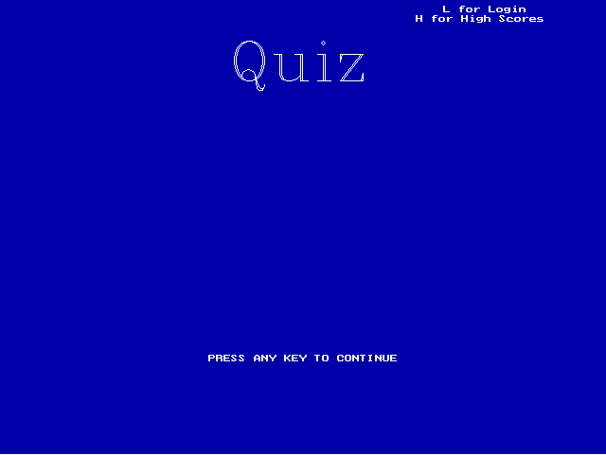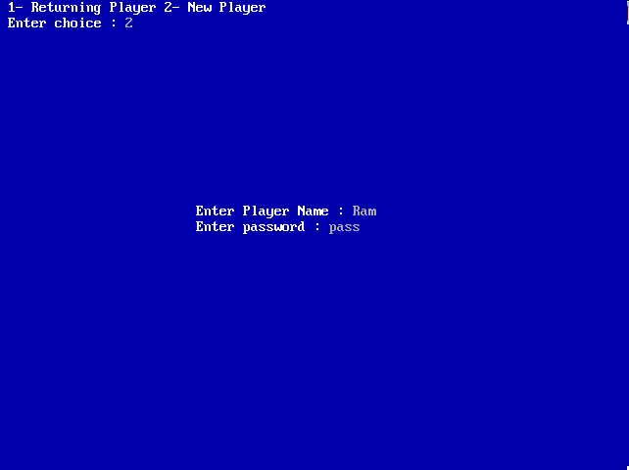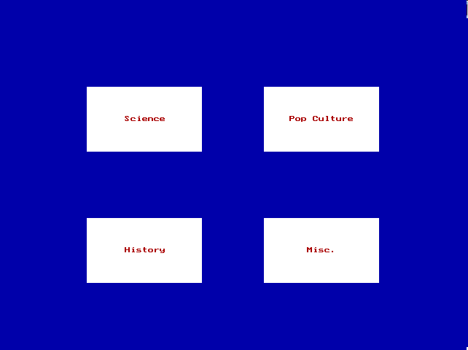

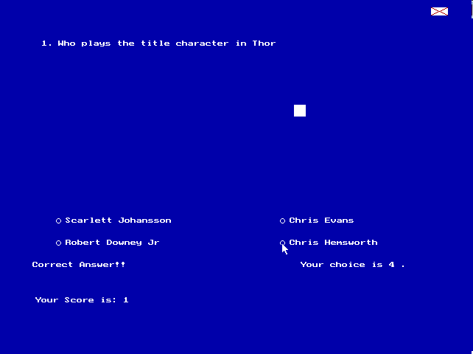

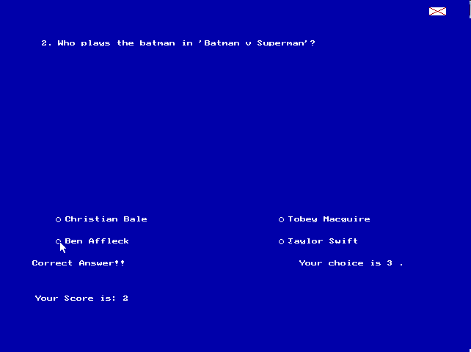

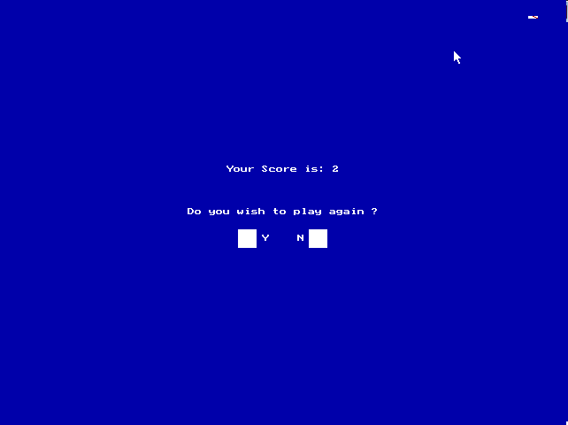

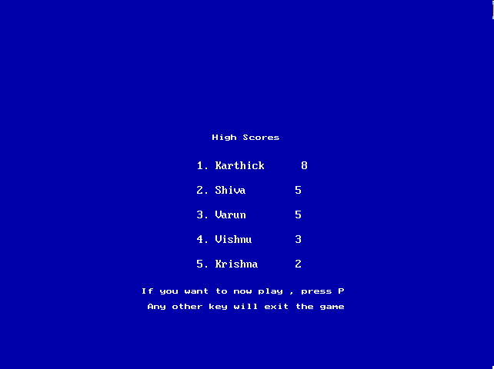

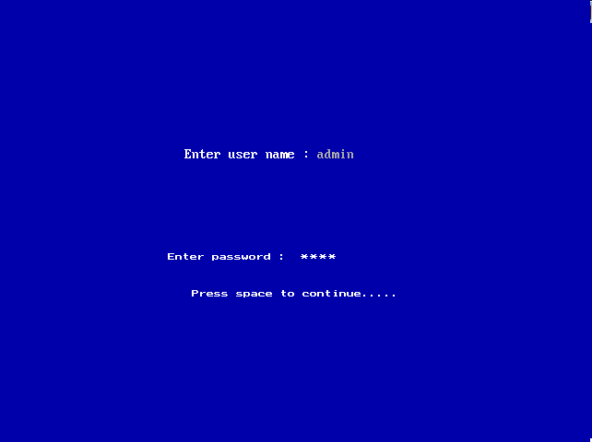

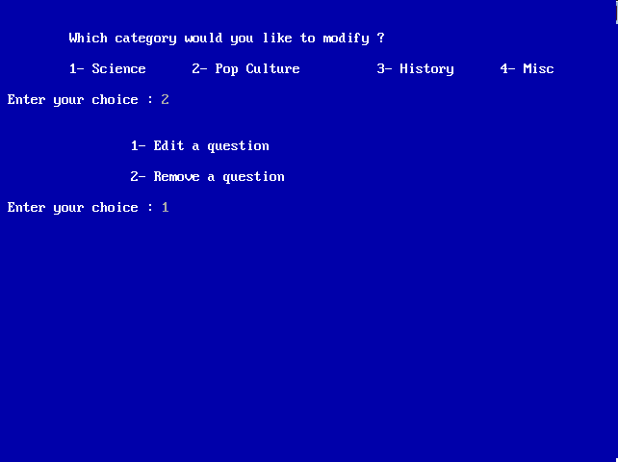

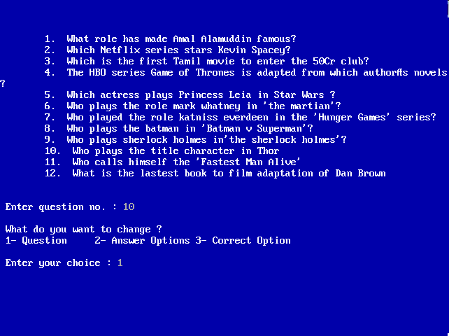

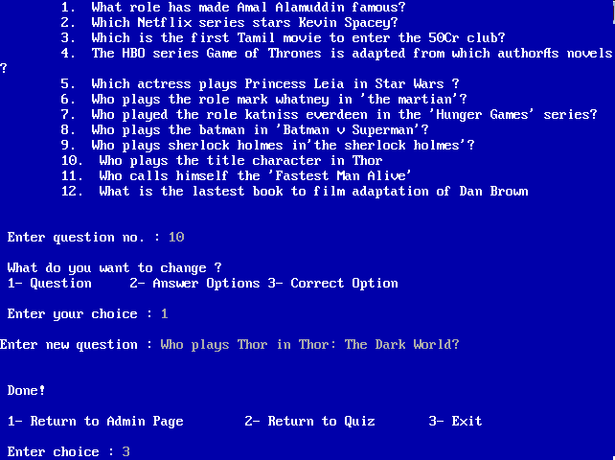

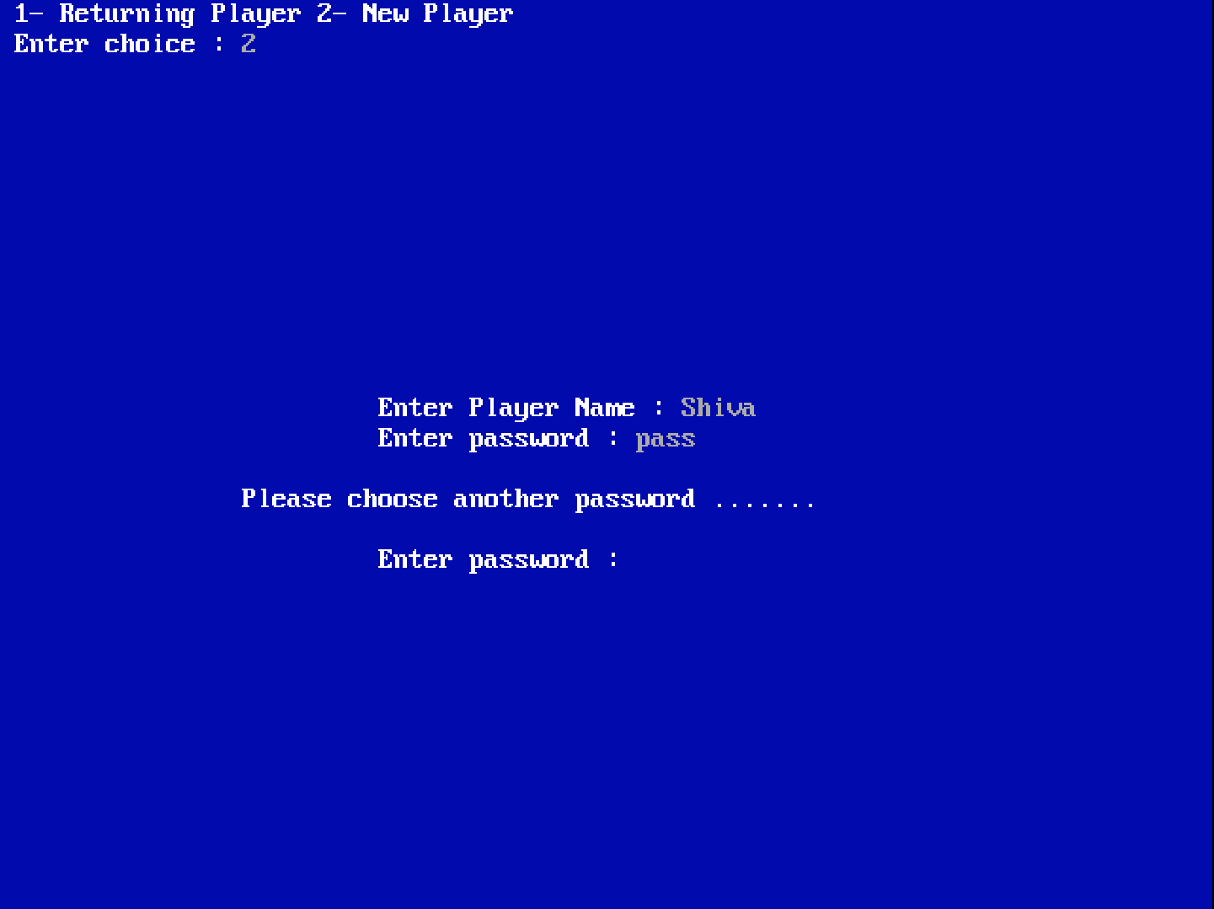

**System Requirements**

Any computer ( built within the past 10 years ) will be able to run the program perfectly fine as it isn’t resource intensive . It has an extremely small foot print so disc space isn’t an issue either. The only main requirement is that TurboC3 is installed to compile the code . The program can scale to any display resolution and text alignment will not be affected by resolution changes

**Bibliography**

The information required for this project was obtained from

* https://stackoverflow.com/
* Sumita Arora – Class 12 Computer Science